**Roll no: 2016-CE-72**

FYP ASSIGNMENT

**Auto Generation of 3D model from room images**

This is the system that will:  
• Allow users to import the image of 2D floor plan.  
• Automatically generate 3D model according to 2D floor plan.  
• Enables users to change the texture of floor and walls in 3D generated model.  
• Enables users to add furniture in 3D generated model.  
• Have different viewpoints i.e. top-view, walk-through, front-view and side-view of 3D generated model.

**PLO1, CLO1: To apply knowledge of mathematics to complex engineering problems.**

For the purpose of generating 3D models, we have to do graphics programming which includes a lot of mathematics mainly linear algebra i.e. we have to specify coordinates, position, scaling and orientation of 3D model.

**PLO2, CLO2: To verify, through research and analysis, the solution to complex engineering problem.**

We proposed our solution and after reading some research papers and analysis of existing systems, we verify our solution and make necessary changes.

**PLO3, CLO3: Design a solution to solve complex engineering problems.**

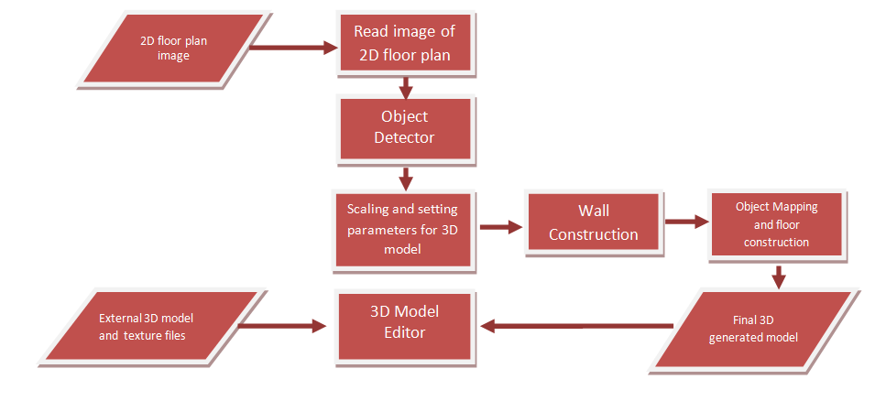

**PLO4, CLO4: To derive valid conclusion after investigating complex engineering problems.**

Our system provides ability to users to generate and edit 3D models before actual investment of their money for making home in real environment. Home-planners, architects and interior designers also use this software to generate 3D model according to imported 2D floor plan image for the purpose to satisfy their customers.

**PLO5, CLO5: To utilize modern computational and analytical tools in solution of complex engineering problems.**

We will develop a unity based desktop application. Programming language will be C#. For the purpose of image recognition and image processing, we will use Python 3.6. The techniques of image recognition and computer graphics will be used to develop this application.

**PLO6, CLO6: To develop ability to assess social, health, safety, legal and cultural issues in finding solutions to complex engineering problems.**

We assess legal, social and health issues. Legal issue like plagiarism can occur but we check and go-through each and everything to avoid this. We can assess health issue and if occur we take necessary steps. We try best not to occur or how to handle any social issue like any kind of personal issue There is no cultural and safety issue occur so far and we assess it daily.

**PLO7, CLO7: To assess environmental and sustainability issues in solving complex engineering problems**

Sustainability is the ability of an organization to continue its mission. As the project is complex and time duration is short. There might be sustainability issue occur and we assess them daily. We do each thing in organized way follow our schedule and instruction of our advisor. We always check that any problem might occur in future and what should be our respond to it. We make sure that project sustain financially because there is no such cost required for the development of this system. After assessment we can say there is no environmental issue occurs so far.

**PLO8, CLO8:** **To demonstrate high ethical and moral values in solving complex engineering problems.**

We try our best to follow professional code of ethics to avoid any problem. If any issue occurs, we resolve it by listening each other argument or opinion. Our mentors also guide us.

**PLO9, CLO9: To develop ability to work in team in solving complex engineering problems.**

We make schedule for each task with date and time of completion. As a group leader I divide tasks and assign tasks to the group members according to their abilities. We listen each other views with patience.

**PLO10, CLO10: To write an effective and methodical document narrating the literative search, problem formulation and solution, methodology adopted and the conclusion drawn in solving a complex engineering problem.**

We recently wrote feasibility report which includes all of these things.

**PLO11, CLO11: To demonstrate management skills in handling the project team.**

Through effective communication, confidence, fairness, respect and adaptability I manage the project team.

**PLO12, CLO12: To recommend innovation in future work to improve proposed solution to the complex engineering problems.**

We can add other input formats of floor plans like .dfx and .svg because many softwares draw floor plan and save files in these formats. Another innovation can be we can make this project through API’s of already existing system, which might save us from lot of effort. Another innovation can be to design more efficient algorithm that detect and recognize objects in 2D floor plan more efficiently.